 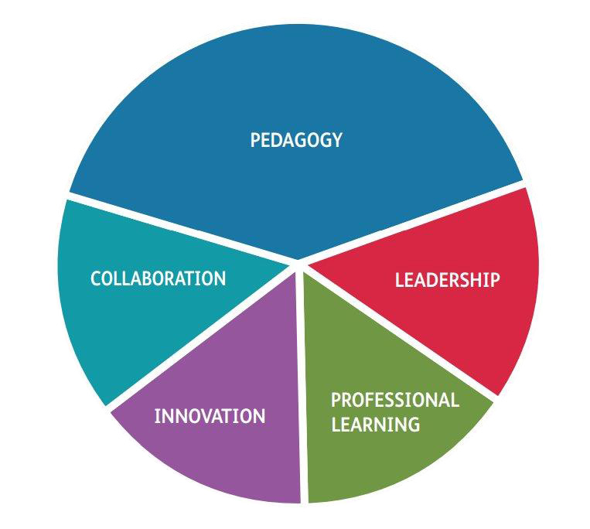

Professional Teaching and

Leadership Standards

2023-24 Assessment Handbook

|  |
| --- |
| Contents |

Tracking Progress 2

The Four Purposes of Learning 4

How to assess using the Professional Standards for Teaching and Leadership (PSTL) 4

Assessment Forms 6

The Professional Journal: Lesson Evaluations 7

The Pedagogy Assessment Form 8

The School Experience Report 9

Linking assignments to the standards 10

Overarching values and dispositions 11

Working with the PSTL 12

Action Exemplar 13

Pedagogy: Refining teaching 14

Pedagogy: Advancing learning 15

Pedagogy: Influencing Learners 16

Collaboration 17

Leadership 18

Innovation 19

Professional learning 20

The PLP (Professional Learning Passport) 21

Terminology 22

The Standards Workbook **Gwall! Dalennod heb ei diffinio.**

Workbooks and the Welsh Portfolio 23

Enhanced Support 24

|  |
| --- |
| Tracking Progress |
| ATs’ progress will be tracked formatively throughout the course, using the Pedagogy Assessment Forms (PAF). At key assessment points they will receive a summative progress grade (see below) and at the end of the course they will receive a grade reflecting their final attainment at QTS |

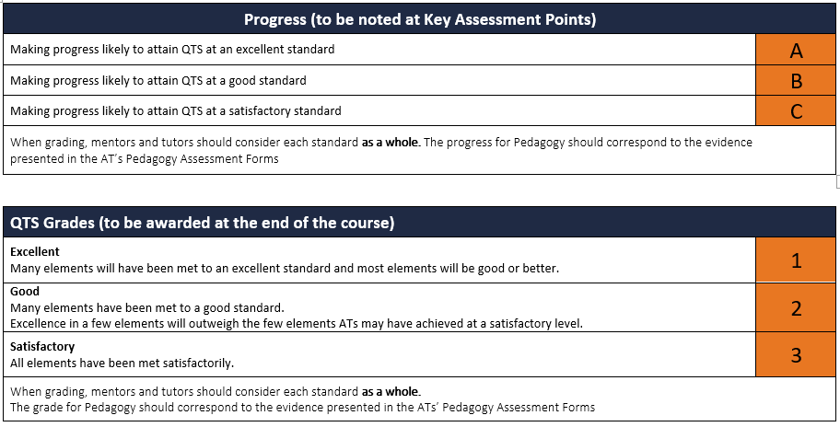

Return to menu

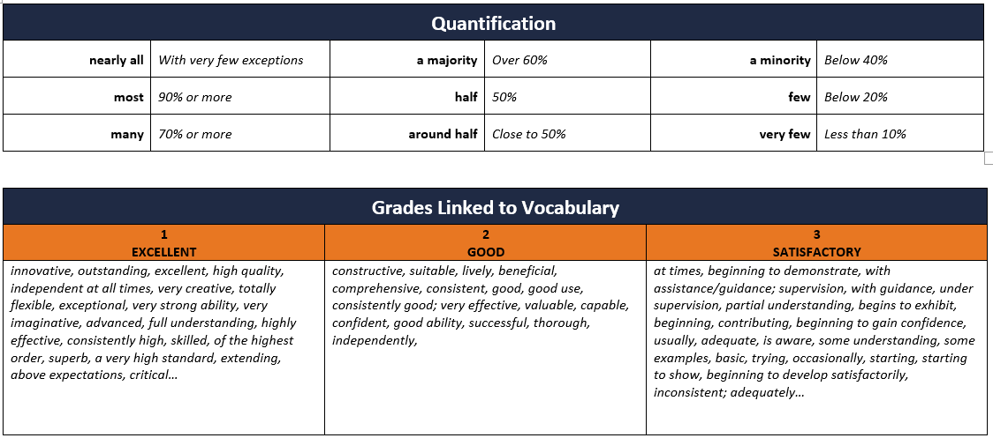

Return to menu

# The Four Purposes of Learning

|  |  |
| --- | --- |
| **Ambitious, capable learners, who ready to learn throughout their lives**  *ATs should enable learners to:*   * set themselves high standards and seek and enjoy challenge * build up a body of knowledge and have the skills to connect and apply that knowledge in different contexts * ask their own questions and enjoy solving problems * communicate effectively in different forms and settings, using both Welsh and English * explain the ideas and concepts they are learning about * use number effectively in different contexts * understand how to interpret data and apply mathematical concepts * use digital technologies creatively to communicate, find and analyse information * undertake research and evaluate critically what they find.   **Ethical, informed citizens of Wales and the world, ready to be citizens of Wales and the world**  *ATs should enable learners to:*   * find, evaluate and use evidence in forming views * engage with contemporary issues based upon their knowledge and values * understand and exercise their human and democratic responsibilities and rights * understand and consider the impact of their actions when making choices and acting * know about their culture, community, society and the world, now and in the past * respect the needs and rights of others, as a member of a diverse society * show their commitment to the sustainability of the planet. | **Healthy, confident individuals, who are ready to lead fulfilling lives as valued members of society**  *ATs should enable learners to*   * have secure values and establish their spiritual and ethical beliefs * build their mental and emotional well-being by developing confidence, resilience and empathy * apply knowledge about the impact of diet and exercise on physical and mental health in their daily lives * know how to find the information and support to keep safe and well * take part in physical activity * take measured decisions about lifestyle and manage risk * have the confidence to participate in performance * form positive relationships based upon trust and mutual respect * face and overcome challenge * acquire the skills and knowledge to manage everyday life as independently as they can.   **Enterprising, creative contributors, ready to play a full part in life and work**  *ATs should enable learners to:*   * connect and apply their knowledge and skills to create ideas and products * think creatively to reframe and solve problems * identify and grasp opportunities * take measured risks * lead and play different roles in teams effectively and responsibly * express ideas and emotions through different media * give of their energy and skills so that other people will benefit. |

Return to menu

|  |
| --- |
| How to assess using the Professional Standards for Teaching and Leadership (PSTL) |

The PSTL are primarily a formative assessment tool for the development of excellent ATs. They should be used to focus on aspects of the AT’s practice which need improvement, to guide their critical reflection on teaching and learning and to frame the conversations they have with their mentors and tutors. In addition, individual elements within the five standards (*Pedagogy, Collaboration, Leadership,* and *Innovation*) can be used to create targets for improvement and foci for lesson observations.

The following pages show the elements, QTS descriptors and suggested attributes of practice which can represent evidence towards meeting that particular standard. However, these attributes of practice are neither a checklist nor are they exclusive; ATs do not have to demonstrate all attributes of practice to meet a specific standard and there may be evidence which is not included in the list.

Whenever evidence is considered, it is unlikely to be limited to one element and the table below shows examples of activities which could address multiple elements.

|  |  |
| --- | --- |
| Activity or Incident | Linked Elements |
| The AT manages whole class discussion effectively enabling learners to answer at length. She then responds appropriately to their responses. | ***Managing the learning environment; Assessment; Listening to Learners.*** |
| The AT is given a target to improve differentiation using open tasks. He improves this skill using research evidence and uploads tasks and learners’ work to the PLP. | ***Differentiation; Progression in learning; Learning outcomes and well-being;* *Wider reading and research findings; Seeking advice and support.*** |
| The AT shadows a head of year at a parents’ evening and notes how the teacher responds to a concerned parent. | ***Involving partners in learning;******Working with in-school colleagues;******Leading colleagues, projects and programmes; Supporting formal leadership roles.*** |
| As a result of the Action Research Project, the AT creates a new cross curricular project for year 4 and shares it with their mentor and the year 3 teacher. | ***Cross-curricular themes;******Offering expertise; Developing new techniques; Wider reading and research findings; Professional networks and communities.*** |

**It is the responsibility of the AT to upload evidence continually to the PLP and to share their Standards Workbook with the mentor, the Principal Mentor and their Tutor. Mentors should monitor the use of the PLP throughout the school experience.**

Return to menu

|  |
| --- |
| Assessment Forms |

There are five assessments which facilitate the development and grading of the AT on school experience and each assessment is summarised using a form (exemplars of completed forms can be found on our website and Blackboard/Moodle).

**The** **Professional Journal: Lesson Evaluation** page provides an opportunity for the mentor or teacher to feedback briefly and instantly on a lesson. They also pose a question to stimulate reflection and the AT then responds and evaluates the learning in the lesson.

**The Pedagogy Assessment Form** **(PAF)** formatively assesses the progress of the AT in the classroom and addresses elements of Pedagogy and Welsh language skills.

The number of Pedagogy Assessments received within are noted on the course assessment calendars.

**The Interim Grades (IG)** summarise the AT’s progress using the grades shown on page 3, complementing the PAFs. There is no form.

**The School Experience Report (SER)** is a comprehensive summary of the ATs’ achievements and areas to develop during their two network school placements.

Return to menu

|  |
| --- |
| The Professional Journal: Lesson Evaluations |

1. 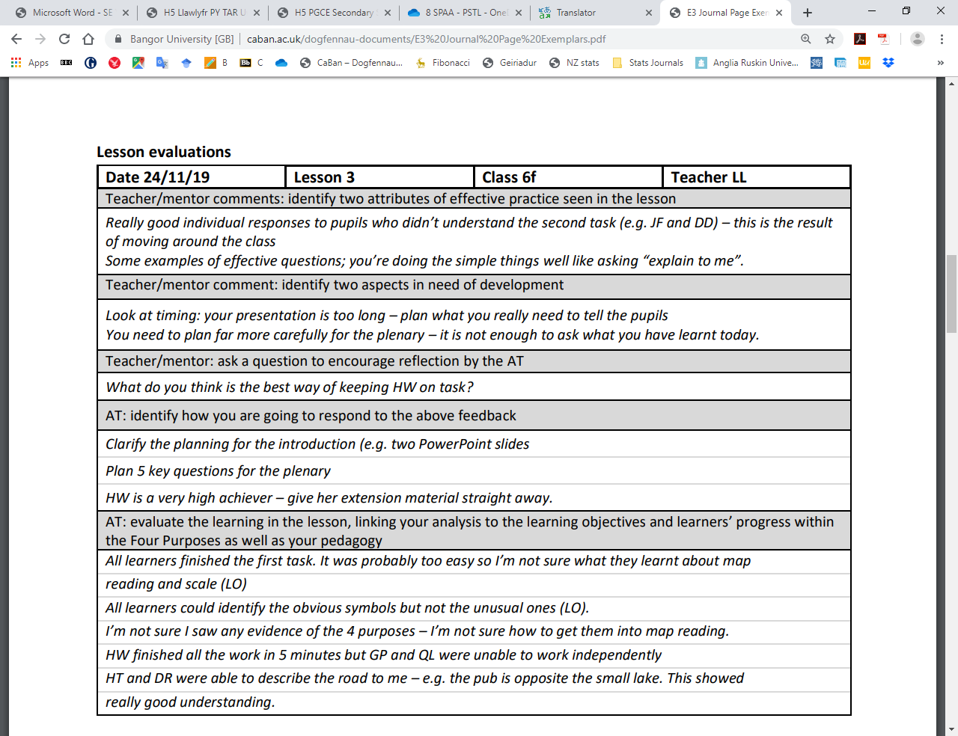For **every** **lesson** taught by the AT, including microteaching and team-teaching sessions, the teacher or mentor present in the room should note briefly two aspects of practice which went well and two in need of improvement
2. The teacher/mentor asks a question of the AT. The question should stimulate the trainee to reflect on a particular aspect of the lesson. For example: *How could you have adapted the activity to enable a more investigative approach by the learners?*
3. The AT responds to the comments and the questions. They identify an action or a small change in their practice which could address some of the teacher/mentor’s concerns.
4. They reflect on the learning in the lesson, using Ebbutt’s questions (included in the Professional Journal) to facilitate their analysis.
5. The AT links the evaluation to a relevant reading and notes relevant standards which may be addressed by the outcomes seen and heard in the lesson

Return to menu

|  |
| --- |
| The Pedagogy Assessment Form |

1. Prior to the observed lesson, the mentor summarises recent teaching progress in the classroom. The summary should include examples of teaching and learning, identify aspects of practice needing development and highlight areas in which the trainee has succeeded in developing their practice. It may also include advice to support that given in meetings.

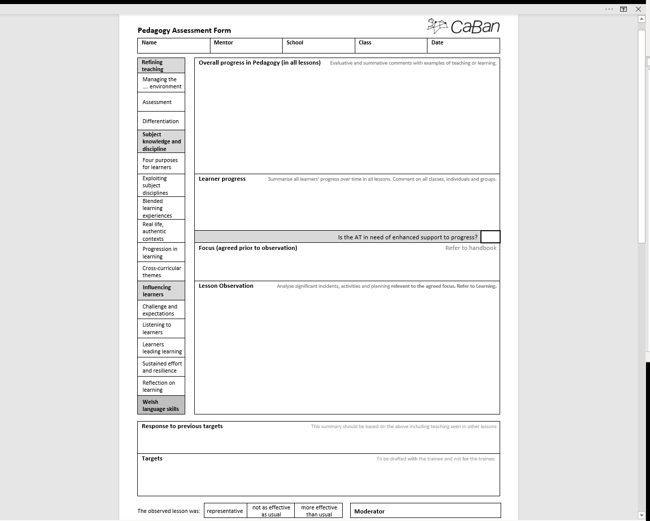

1. Prior to the observed lesson, the mentor summarises learner progress using quantitative terms (page 5). They refer to the class as a whole and to groups and individuals who may or may not have additional needs. **Note that progress should be assessed over a number of lessons.**
2. The mentor decides whether the AT is in need of enhanced support **before** the observed lesson.
3. Prior to the observed lesson, the mentor and trainee should meet to discuss the focus of the observation. The focus should address issues which have arisen in the mentor’s summary of overall progress, be a natural development of previous targets and linked to the elements of Pedagogy detailed on the form.
4. The comments arising from the observation should be relevant to the agreed lesson focus as well as the quality of the learners’ activities during the lesson. However, additional significant incidents may occur and these should be included. **At least two PAFS must mention Welsh language skills.**
5. The mentor decides which standards can be evidenced by the PAF and circles the relevant standards.
6. The trainee and mentor reflect on progress on previous targets and agree on new targets.
7. The mentor and trainee agree whether the lesson is representative of recent practice.
8. The AT completes the review section of the PAF and uploads the form, plans, lesson materials and evidence of learning to the PLP.

An exemplar form can be found on the CaBan website.

Return to menu

|  |
| --- |
| The School Experience Report |

SER

Return to menu

# Linking assignments to the standards

All assignments should be uploaded to the PLP and linked to the relevant standards.

Assignment marks will determine the grades given for **Professional Learning** using the following conversion tables as a guide.

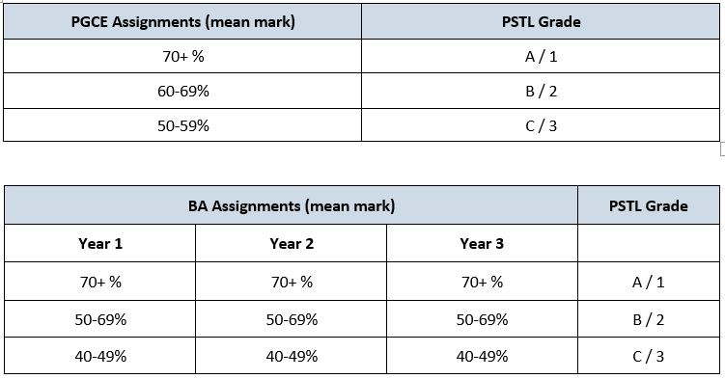

Return to menu

# Overarching values and dispositions

Throughout school experience, ATs should adopt the values and dispositions which support the PSTL.

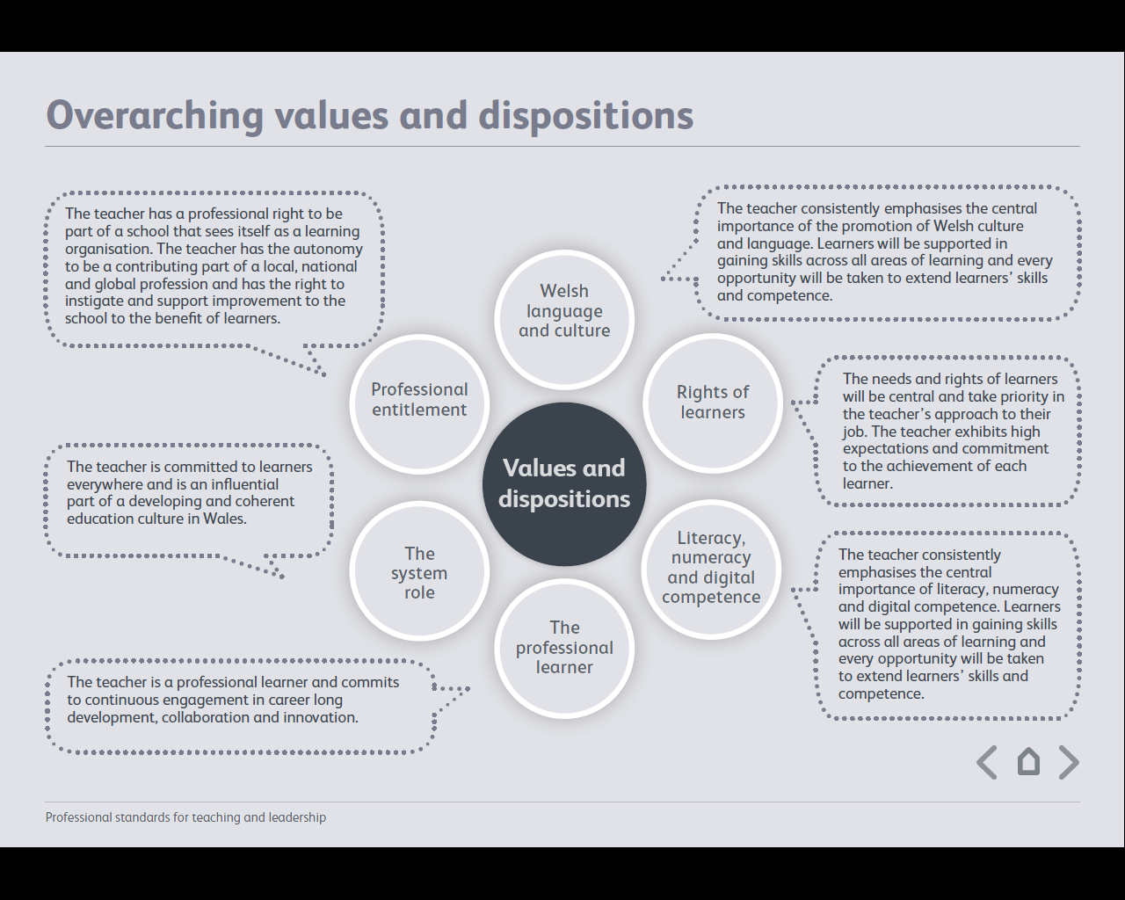

Return to menu

|  |
| --- |
| Working with the PSTL |

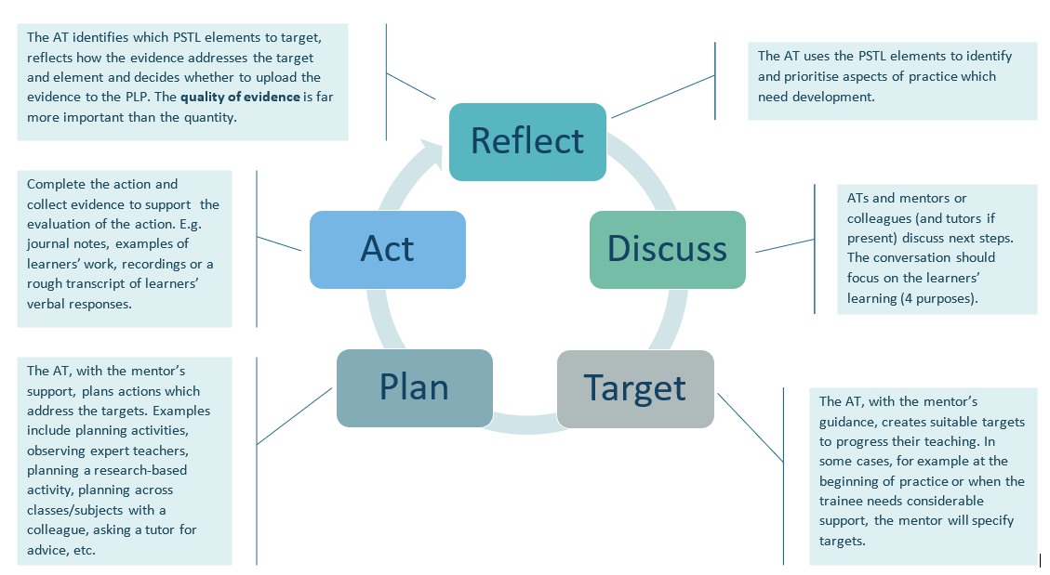

Return to menu

|  |
| --- |
| Action Exemplar |

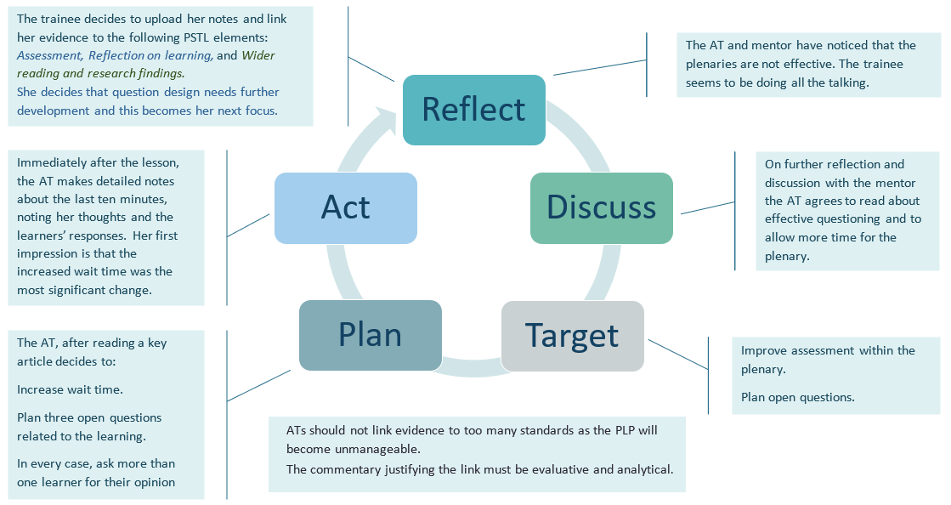Return to menu

# Pedagogy: Refining teaching … towards sustained highly effective practice

|  |  |  |  |
| --- | --- | --- | --- |
| **Element** | **QTS descriptor** | **Practice which satisfies QTS. Satisfactory ATs:** | **Practice which exceeds QTS expectations. Excellent ATs:** |
| **Managing the learning environment** | The teacher understands the importance and demonstrates the effective establishment and on-going management of the learning environment, in promoting positive learning habits and behaviours that meet the four purposes and are understood by learners in that context. | * are beginning to establish good relationships with most learners, both at an individual and classroom level. * in some instances, can respond appropriately to the emotional, behavioural and cognitive needs of most learners. * have satisfactory knowledge of behaviour management strategies and can apply these in a limited range of contexts to ensure effective learning. * make satisfactory use of the time and space available. | * establish excellent relationships with all learners, both at an individual and classroom level. * can respond immediately and appropriately to the emotional, behavioural and cognitive needs of all learners. * have excellent knowledge of behaviour management strategies and can apply these in a variety of contexts to ensure effective learning. * make excellent use of the time and space available. |
| **Assessment** | The range of purposes and practices of assessment is understood and articulated | * can implement assessment practices in the classroom. * are beginning to question effectively and manage the whole class dialogue. * Are beginning to understand how to assess prior knowledge, address misconceptions and assess progress during the lesson and identify the next steps for some learners. * are beginning to plan learning activities informed by prior assessment. * create limited opportunities for learners to self and peer assess | * can implement a wide range of assessment practices in the classroom. * question effectively and expertly manage the whole class dialogue. * understand how to assess prior knowledge, address misconceptions and assess progress during the lesson and identify the next steps for all learners. * ensure curriculum planning and delivery is consistently informed by critical analysis of prior assessment. * create opportunities for learners to self and peer assess consistently and effectively |
| **Differentiation** | The teacher demonstrates knowledge, understanding and experience of high expectations and effective practice in meeting the needs of all learners, whatever their different needs. | * are beginning to plan and implement activities which engage and challenge some learners. * in some cases, link their planning of activities to learners’ previous outcomes and school performance data. * sometimes adapt learning materials to ensure most learners have access to the curriculum. * sometimes plan and implement activities to extend MAT learners. | * plan and implement activities which engage and challenge all learners. * consistently link their planning of activities to learners’ previous outcomes and school performance data. * adapt learning materials to ensure all learners have access to the curriculum. * plan and implement activities which extend and enrich MAT learners |
| **Recording and reporting** | The teacher produces appropriate, timely and accurate records and reports and gives feedback to facilitate a deeper understanding of learning and enhance the learning experience. | * show evidence of recording attainment data according to school policy. * provide satisfactory written feedback. * make satisfactory use of summative data to plan learning. * make a satisfactory contribution when reporting to parents/carers. | * record attainment data accurately and consistently according to school policy. * provide excellent written feedback. * make critical use of summative data to plan effectively, both in the short and long term. * make significant contributions to reports to parents/carers, |
| **Involving partners in learning** | The importance of positive involvement of parent/carers and other partners is understood, and opportunities are taken to observe and evaluate processes. | * have a sufficient understanding of how parents and external partners can contribute to effective learning. * observe and note the communication with parents/carers and others. | * understand how parents and external partners can contribute to effective learning and developing the four purposes. * work with external agencies. * observe, evaluate critically and understand the communication with parents/carers and others. |

Return to menu

# Pedagogy: Advancing learning

|  |  |  |  |
| --- | --- | --- | --- |
| **Element** | **QTS descriptor** | **Practice which satisfies QTS. Satisfactory ATs:** | **Practice which exceeds QTS expectations. Excellent ATs:** |
| **Four purposes for learners** | The teacher demonstrates a knowledge and understanding of the needs of all learners in planning, preparation and teaching, ensuring that the four purposes are the drivers for learners’ experiences. | * ensure learners make satisfactory progress within the Four Purposes over a series of lessons (see page 5). * have some understanding of the implications of the Four Purposes for the subject content, age and prior attainment of the learners. * have a sufficient understanding of how different pedagogies can facilitate the development of the Four Purposes * understand the relevance of some activities to the Four Purposes | * ensure learners make excellent progress within the Four Purposes over a series of lessons (see page 5). * have excellent understanding of the implications of the Four Purposes for the subject content, age and prior attainment of the learners. * understand how different pedagogies can facilitate the development of the Four Purposes * understand the relevance of all curriculum content to the Four Purposes |
| **Exploiting subject disciplines in AoLEs** | The teacher demonstrates a knowledge and understanding of relevant pedagogies and disciplines within and across subject content, areas of learning and cross-curricular themes, and plans appropriately. | * plan satisfactory lessons which achieve the four purposes. * have a satisfactory understanding of the subject content. * understand, plan and implement a limited range of pedagogies. * have a sufficient understanding of how a topic is situated within a particular AoLE and/or subject. * plan satisfactory activities which develop learners’ digital competence, literacy and numeracy | * plan excellent lessons and series of lessons which achieve the four purposes. * have an excellent understanding of the subject content. * understand, plan and implement a range of pedagogies. * understand how a topic is situated within a particular AoLE and/or subject. * plan excellent activities to develop learners’ digital competence, literacy and numeracy |
| **Blended learning experiences** | The teacher understands the selection, use and justification of a range of imaginative teaching approaches for the benefit of each learner. | * adopt a sufficient range of pedagogies and learning environments, including, for example, group work, role play, problem-based learning, web-based activities, off-site visits, outdoor areas, VLEs, etc. * deliver a satisfactory range of satisfactory learning resources; for example, models, worksheets, sorting activities, electronic, games, etc. | * adopt a wide range of effective pedagogies and learning environments, including, for example, group work, role play, problem-based learning, web-based activities, off-site visits, outdoor areas, VLEs, etc. * devise and deliver a range of innovative learning resources; for example, models, worksheets, card sorting activities, electronic, games, costumes, etc. |
| **Real life, authentic contexts** | The teacher demonstrates an understanding of the use of real life, authentic contexts for learning being provided as a natural part of the learning experience. This extends the learner’s cultural, linguistic, religious and socio-economic experience and illustrates applications of concepts and abstracts in practice. | * present curriculum content within contexts which link with the real world. * develop some learners’ knowledge of Wales and Welsh culture. * have a limited understanding of how context can enhance and develop cognitive skills in all learners. * have a sufficient understanding of the role of context when developing learners’ digital competence, literacy and numeracy. | * present curriculum content within imaginative, relevant and valid contexts which emphasise links with the real world. * develop learners’ knowledge of Wales and Welsh culture through meaningful, context rich activities. * understand how context can enhance and develop cognitive skills in all learners. * understand the role of context when developing learners’ digital competence, literacy and numeracy |
| **Progression in learning** | The teacher demonstrates an understanding of how learning develops incrementally and tangentially, building on prior experience and learning, and plans for progress in learning based on this. | * have a satisfactory knowledge of curriculum requirements in preceding and subsequent stages of learning. * demonstrate a satisfactory knowledge of how prior learning can facilitate learner progress. * can plan lessons and/or activities which support the learning of some learners who have ALN | * are familiar with curriculum requirements in preceding and subsequent stages of learning. * demonstrate how knowledge of prior learning and designing valid learning objectives can facilitate learner progress. * can plan lessons and/or activities which significantly progress the learning of learners who have ALN |
| **Cross-curricular themes** | The teacher knows, understands and engages with the principles of curriculum design and innovation, with development of cross-curricular themes relevant to areas of learning and justifies decisions. | * plan and teach satisfactory cross-curricular learning experiences, making satisfactory connections with other AoLEs/subjects. * demonstrate a satisfactory understanding of curriculum design. * ensure some learners make progress in all CCRs. | * plan and teach excellent cross-curricular learning experiences, making relevant meaningful connections with other AoLEs/subjects. * plan activities with other teachers from other subjects. * demonstrate an excellent understanding of curriculum design. * ensure learners make excellent progress in all CCRs. |

Return to menu

# Pedagogy: Influencing Learners

|  |  |  |  |
| --- | --- | --- | --- |
| **Element** | **QTS descriptor** | **Practice which satisfies QTS. Satisfactory ATs:** | **Practice which exceeds QTS expectations. Excellent ATs:** |
| **Challenge and expectations** | The teacher provides appropriate levels of challenge and expectations for the range of student abilities and characteristics, motivating learners to achieve. | * have satisfactory expectations of all learners’ learning and behaviour. * plan and implement activities which challenge most learners. * makes use of a satisfactory range of communication methods to stimulate learners’ interest, motivation and engagement. * have reasonable expectations of all learners, regardless of their race, creed, gender, sexual orientation and socio-economic status. | * have high expectations of all learners’ learning and behaviour. * plan and implement engaging, challenging activities. * makes use of a wide range of communication methods to stimulate learners’ interest, motivation and engagement. * have high expectations of all learners, regardless of their race, creed, gender, sexual orientation and socio-economic status. |
| **Listening to learners** | The teacher demonstrates a willingness to seek, listen to and take account of the views of learners in order to engage and encourage them as active participants in their own learning. | * show some evidence of listening to learners in class and may sometimes respond appropriately, both emotionally and intellectually. * are beginning to facilitate effective whole class discussion. * make satisfactory use of the views of learners when planning or evaluating teaching and learning. | * listen to learners in class and respond with understanding and insight, both emotionally and intellectually. * facilitate discussion on issues which are open-ended, complex, controversial or emotional. * seek the views of learners when planning or evaluating teaching and learning |
| **Learners leading learning** | In planning and delivery, the teacher demonstrates an awareness of the importance of encouraging learners to reflect upon their own learning. | * create sufficient opportunities for learners to self and peer assess effectively. * are beginning to involve learners when designing learning objectives. | * create opportunities for learners to self and peer assess consistently and effectively * involve learners when designing learning objectives. |
| **Sustained effort and resilience in learners** | The teacher promotes and secures learners’ self-motivation and self-direction in their learning. | * design some activities which encourage independent learning * are sometimes able to motivate learners to be persistent and to ask for help when needed. * are beginning to create a learning environment which values and celebrates hard work and achievement. | * design activities which encourage independent learning and which develop learners’ initiative. * motivate learners to be persistent, to view problems as challenges, not obstacles, and to ask for help when needed. * create a learning environment which values and celebrates hard work and achievement. |
| **Reflection on learning** | In planning, the teacher demonstrates awareness of the importance of encouraging learners’ reflection and evaluation around behaviours and outlooks for learning. | * are beginning to equip learners with resources which enable them to plan and reflect on their learning, e.g. checklists, rubrics and organisers. * sometimes deliver plenaries which encourage self-monitoring of learning. | * ensure that all learning is reflective and that learners become conscious of how and what they have learnt. * equip learners with resources which enable them to plan and reflect on their learning, e.g. checklists, rubrics and organisers. * consistently deliver plenaries which encourage self-monitoring of learning. |
| **Learning outcomes and well-being** | The teacher raises awareness of how high-quality learning experiences and performance outcomes lead to improved learning and a heightened sense of well-being. | * sometimes ensure learner progress is linked to their well-being. * are beginning to create a learning environment which encourages co-operation between learners. * show some evidence of planning tasks which lead to progress for most learners. | * ensure that learner progress is linked to their well-being. * create a learning environment which encourages mutual support and co-operation between learners * ensure that task design leads to success and progress for all learners. |

Return to menu

# Collaboration

|  |  |  |  |
| --- | --- | --- | --- |
| **Element** | **QTS descriptor** | **Practice which satisfies QTS. Satisfactory ATs:** | **Practice which exceeds QTS expectations. Excellent ATs:** |
| **Seeking advice and support** | The teacher actively seeks and engages with support from a range of formal and informal sources. This includes observation and team teaching, whilst demonstrating increasing levels of independence. | * are beginning to progress satisfactorily through team teaching and joint planning with mentors. * reflect on their own practice and sometimes seek advice from their mentor. * are mostly able to act on advice and feedback and are beginning to improve their own practice. | * develop their practice through team teaching and joint planning with mentors, peers and other professionals. * reflect on their own practice critically and seek advice independently from school, HEIs and wider sources. * are able to act on advice and feedback, improve their own practice and develop their wider skills independently. * engage with mentors, colleagues, tutors and peers for support and advice to co-evaluate and reflect collaboratively on learning and teaching. |
| **Working with in-school colleagues** | Organised and constructive work with a range of colleagues to enhance learners’ experience is a consistent feature of the teacher’s practice. Reflection on developing expertise is structured as a personal or a collaborative process, as appropriate. | * develop satisfactory relationships with the mentor and colleagues, * have sufficient engagement in the processes of curriculum development in the school | * develop excellent relationships with the mentor, and, as opportunities arise, in the wider learning community with colleagues, parents/carers and external agencies. * engage where possible in the processes of curriculum development, improvement planning and professional review and development in the school |
| **Supporting and developing others** | The teacher develops high quality relationships with colleagues in order to have a positive impact upon learners’ experiences within the school. | * participate in professional learning with others. * show evidence of sharing some learning experiences with peers. | * participate in professional learning with others, engaging in group reflection, learning and practice * lead learning through sharing successful experiences with colleagues |
| **Enabling improvement** | There are examples of improvement in outcomes for learners following the teacher’s seeking and adoption of advice. | * share instances of professional learning with colleagues to support improved performance and outcomes for some learners. * are beginning to adopt practices which result in a limited improvement in learner outcomes. * make some improvement in their own practice when given advice. * make sufficient use of theory and research in practice. | * share professional learning with colleagues to support improved performance and outcomes for all learners. * adapt existing practices and adopt new strategies which result in improved learner outcomes * improve their own practice as a result of independent critical reflection * apply theory and research in practice and evaluate the resulting progress of learners |

Return to menu

# Leadership

|  |  |  |  |
| --- | --- | --- | --- |
| **Element** | **QTS descriptor** | **Practice which satisfies QTS. Satisfactory ATs:** | **Practice which exceeds QTS expectations. Excellent ATs:** |
| **Taking responsibility for self** | The teacher demonstrates professional attitudes and behaviours, developing positive relationships with learners, parents/carers and colleagues, which illustrate a personal commitment to the fundamental principles of equity and of maximising the potential of all learners. | * make a satisfactory contribution to other areas of school life, e.g. through extra-curricular activities * have a satisfactory understanding of the concept of equity in education and how schools can make a difference * have a sufficient understanding of the association of child poverty with low educational achievement * achieve satisfactory levels of literacy and numeracy in their own professional practice. * develop excellent ICT skills within their own professional practice. | * make significant contributions to other areas of school life, e.g. through extra-curricular activities * understand the concept of equity in education and how schools can make a difference * understand the association of child poverty with low educational achievement * achieve excellent levels of literacy and numeracy in their own professional practice. * develop excellent ICT skills within their own professional practice. |
| **Exercising corporate responsibility** | Contractual, pastoral, health and safety, legal and professional responsibilities are known and understood by the teacher. | * demonstrate sufficient knowledge of safeguarding, anti-bullying measures and related procedures * work within school policies (e.g. restraint, inclusion, ……….) * have a sufficient understanding of how schools implement government policy | * demonstrate an in-depth knowledge of safeguarding, anti-bullying measures and related procedures * understand and work within school policies (e.g. restraint, inclusion, ……….) * understand how schools implement government policy |
| **Leading colleagues, projects and programmes** | The teacher’s understanding of, and commitment to, leading learning is demonstrated through collaborative experiences in schools and other contexts. | * observe colleagues in their roles as educational leaders in the school * work within the school’s professional structures as directed by the mentor * attend relevant meetings regularly * have a satisfactory understanding of how target setting can improve standards | * observe colleagues in their roles as educational leaders in the school * understand and work within the school’s professional structures * attend relevant meetings regularly and reflect critically on their significance and effect * understand how target setting can improve standards |
| **Supporting formal leadership roles** | The teacher demonstrates an understanding of the nature of responsibilities within and across teams and of the contributions individuals make towards the school’s ethos and the successful fulfilment of the school’s vision. | * have a sufficient understanding of the nature of responsibilities within and across departments and teams in the school * begin to adopt the school’s ethos and vision and apply some policies in practice | * understand the nature of responsibilities within and across departments and teams in the school * adopt the school’s ethos and vision and regularly apply a range of policies in practice |

Return to menu

# Innovation

|  |  |  |  |
| --- | --- | --- | --- |
| Element | QTS descriptor | Practice which satisfies QTS. Satisfactory ATs: | Practice which exceeds QTS expectations. Excellent ATs: |
| **Offering expertise** | The teacher models an increasing repertoire of teaching techniques, as expertise emerges and flourishes, in order to inform and enhance the development of others. | * share practice with peers and school colleagues * exhibit a sufficient range of pedagogies which are focused on learning and which have been adapted to the needs of some learners. | * share excellent practice with peers and school colleagues. * exhibit a range of pedagogies which are focused on learning and which have been adapted to the needs of the learners. * influence the practice of their mentor and the wider school. |
| **Developing new techniques** | Research on cognitive, social, emotional and physical development has a positive impact upon pedagogy. The teacher can demonstrate how professional discernment and critical analysis are brought to bear in shaping developing practice. | * make limited adaptations to practice as a result of reading research. * have a satisfactory understanding of how cognition, behaviour, discussion and motivation are affected by different pedagogies. * are beginning to analyse learners’ behaviour, learning and emotions as a result of their understanding of research and theory. | * develop new ways of working as a result of reading research and theory * demonstrate how practice is theory based and understand how cognition, behaviour, discussion and motivation are affected by different pedagogies * analyse learners’ behaviour, learning and emotions as a result of their understanding of research and theory |
| **Evaluating the impact of changes in practice** | The teacher actively seeks support and advice from colleagues in developing innovative approaches within the classroom so that their impact can be evaluated, analysed and shared. | * gather sufficient data and have a satisfactory understanding of how evidence can evaluate the impact of changes in practice. * have a satisfactory understanding of how to interpret qualitative and/or quantitative data. * are beginning to solve problems arising in the classroom. | * gather rich, informative data and understand the value of a range of data and other evidence in evaluating the impact of changes in practice. * Understand in depth how to interpret qualitative and quantitative data and other evidence of learning outcomes. * think critically, analyse, and solve problems, as an individual and a member of a team. |

Return to menu

# Professional learning

|  |  |  |  |
| --- | --- | --- | --- |
| **Element** | **QTS descriptor** | **Practice which satisfies QTS. Satisfactory ATs:** | **Practice which exceeds QTS expectations. Excellent ATs:** |
| **Wider reading and research findings** | The teacher demonstrates an increasingly confident understanding of the theories and research about assessment, pedagogy, child and adolescent development and learning relevant to planning and day-to-day practice. | * engage with a sufficient range of education theory and research texts. * have a satisfactory understanding of research into learning, pedagogy, assessment and child and adolescent development. * are beginning to apply research and theory to their own practice, thus improving outcomes for some learners. | * engage with a wide range of education theory and research texts critically. * have a deep understanding of research into learning, pedagogy, assessment and child and adolescent development. * are able to apply research and theory to their own practice, thus improving learner outcomes. |
| **Professional networks and communities** | The teacher has an informed understanding of the contribution of research, including small scale action research, to the development of practice. | * implement a small-scale action research cycle, analyse learner outcomes and reflect on their own practice. * have a satisfactory understanding of how to collect relevant data from the classroom, including observation data, evidence of learning, and quantitative attainment data. | * implement an excellent small-scale action research cycle, analyse learner outcomes and reflect critically on their own practice. * understand how to collect relevant data from the classroom, including observation data, evidence of learning, and quantitative attainment data * are able to understand others’ research and critically evaluate its relevance to their own practice and context |
| **Continuing professional learning** | The Professional Learning Passport influences the ongoing critical reflection and learning of the teacher and is developmental in prompting further professional growth. | * use the PLP to reflect on their progress but rely on their mentor and tutor to set targets. * present satisfactory evidence of their progress to the PLP. * make sufficient use of their PLP when discussing their progress with their mentor. | * use the PLP to reflect on their progress and, with their mentors and tutors, form challenging targets for future development * regularly present evidence of their progress to the PLP alongside commentary which is critical, analytical and linked to theory and research * use their PLP to facilitate professional dialogue with their mentor, tutor and other colleagues. |
| **Welsh language skills** | There is a commitment to incremental development of personal skills in the use of the Welsh language. | * make satisfactory improvement in their use of the Welsh language in the classroom. * make satisfactory progress in their knowledge, use and application of Welsh as evidenced by National accreditation. * make limited improvement in the quality of their written Welsh in the school context and, where relevant, within assignments. | * significantly increase and improve their use of the Welsh language in the classroom and with colleagues. * succeed in improving and increasing learners’ use of Welsh in the classroom. * make excellent progress in their knowledge, use and application of Welsh as evidenced by National accreditation. * significantly improve the quality of their written Welsh in the school context and, where relevant, within assignments. |

Return to menu

# The PLP (Professional Learning Passport)

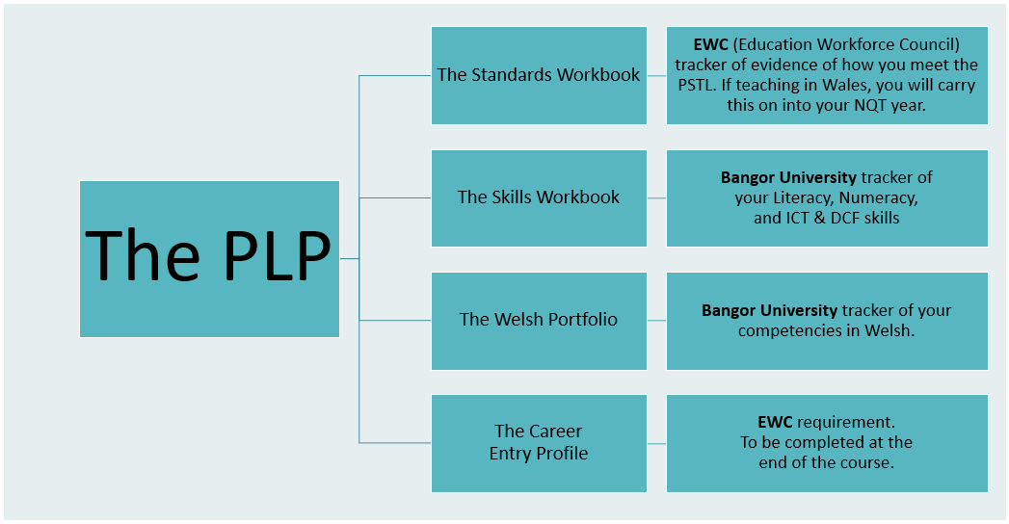

Return to menu

# Terminology

**EWC** The Education Workforce Council. The Education Workforce Council is the regulator in Wales for teachers in maintained schools, further education teachers and associated learning support staff.

**PLP** The Professional Learning Passport. The PLP is an EWC bilingual and flexible online tool available to all registrants. Your PLP is packed with features that are designed to support you in capturing, reflecting upon, sharing and planning your learning with the aim of improving your practice.

**Standards Workbook** EWC ongoing tracker of evidence of how you meet the Teaching Standards. If teaching in Wales, you will carry this on into your NQT 1st year.

**Skills Workbook** Bangor University’s ongoing tracker of your Literacy, Numeracy, and ICT (Information and Communications Technology) & DCF (Digital Competency Framework)

**The Welsh Portfolio** This workbook collates your experiences, feedback and skill levels in Welsh

**The Career Entry Profile** The **CEP** provides a summary of your unique initial teacher education (ITE) and helps you prepare for your statutory induction period at the start of your professional practice as a teacher.

**Template** A template provides a framework for uploading evidence

**PAF**  Pedagogy Assessment Form – is the document completed by the mentor and AT when an identified individual lesson is observed. Eight PAF forms will be completed by the end of the course.

**PET**  Professional Experience Template – is a template in your PLP when you document an individual or series of experiences in which you learn and develop your teaching practice which can then be used as evidence against any of the elements i.e. (this is not an exhaustive list) school training day, educational school visit, observing other teachers/ATs, departmental/team meetings, school Eisteddfod.

**Asset** An asset is a template with accompanying evidence.

**Element**  An element describes an aspect of professional practice within one of the five standards.

Return to menu

# Workbooks and the Welsh Portfolio

Share the HTML links to the Workbooks with your Link Tutor and Mentors, giving them editing rights.

Share the Welsh portfolio in the same way with your Welsh tutor

Complete and upload throughout the course, providing evidence of self-study between audits for literacy and numeracy.

**Monitoring the Workbooks**

There are several Review Points throughout the course. You will be provided with the dates and requirements at the start of your course. Ensure your workbooks are up to date as by these Review Points. Requirements will differ from course to course and details and dates will be provided on Blackboard.

At the end of your course the following will be assessed using the PLP:

**Final Review**

Standards Workbook Pedagogy: 2/3 assets per element;

Professional Learning, Innovation, Collaboration and Leadership: 1/2 assets per element

Skills Workbook All sections, including Google Units 11 - 13

The Welsh Portfolio Parts 2 and 3 and the exit levels

Career Entry Profile All sections

***Refer to the Blackboard PLP Module for further guidance and support including ‘How to,’ videos.***

Return to menu

|  |
| --- |
| Enhanced Support |

|  |  |
| --- | --- |
| It is inevitable that some ATs will need additional support. The following process is a summary of the steps to be taken when an AT is not able to meet the expectations of the course.  If the mentor, Principal Mentor (PM) or tutor believes the AT needs support to progress whilst on school experience the following process should be followed at the earliest opportunity. An AT may receive a maximum of two periods of Enhanced Support during a course and only one during any placement.  * Should the Enhanced Support commence less than three weeks before the end of a placement on the BA course, the AT should be given time to finish their placement in June/July.  For PGCE courses it is unlikely an Enhanced Support will be instigated during the last three weeks of either school placement. However:   * should the Enhanced Support commence during the last three weeks of placement 1 it should continue into placement 2; * should the Enhanced Support commence during the last three weeks of placement 2 the AT should be given additional time to complete their support plan in June/July.   **Note that this is a typical Enhanced Support process. Each case will be addressed on its merits and all processes will conform to the procedures detailed in the CABAN QA Handbook**  Return to menu | Flowchart |